**The genres of *Steam***

Rover Vos

**Intro**

For this assignment, I took a look at the *Steam*(Valve, 2003) categorisation system. I have always found it be to very lacklustre so I wanted to see why that is the case. I wrote this paper in 2 steps. First I write about my observations of the *Steam* categorization system. Afterwards, I discuss what I found.

**Observations**

A user can browse by categories which have 4 elements. The special section, genres, themes and player support. These 4 categories each have their sub-elements. The special section has free-to-play, demo, early access, etc. Genres has action, role-playing, Sports & Racing, etc. And these genres have 7 subgenres. Themes has anime, horror, open-world, survival, etc. Lastly, player support has co-operative, MMO, multiplayer, etc. It is rather confusing and best to take a look at *figure 1*. Outside of *Figure 1* a user can also look at the side of *Steam* and browse by genre(Figure 2). Lastly, users can also browse by category with a carousel(*Figure 5*) and on the side of *Steam*(*Figure 3*).

Besides categories *Steam* also has tags. Tags are a system where users can give games tags. For example giving *Dark Souls* the tag souls-like, Dark Fantasy, RPG, etc. (*FromSoftware, 2011*). If enough users give the same tag to the same game then if you search by the tag that game will pop up. This could become(As of writing it’s in beta) a very nice system as genres are a function of their society(Altman 1999, 26).

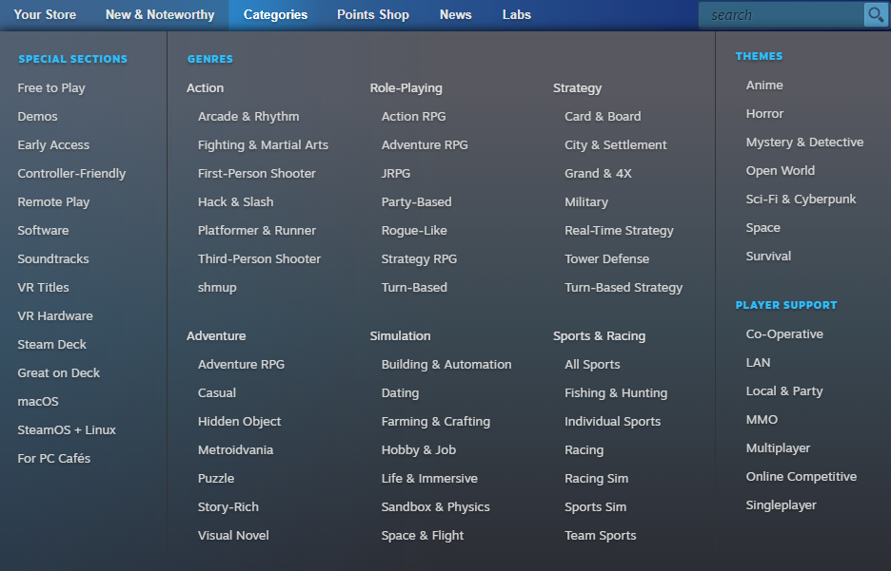

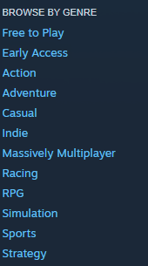Figure Screenshot of Steam categories taken on 29/03/2023

Figure 2 Screen shot Steam side genres taken on 29/03/2023

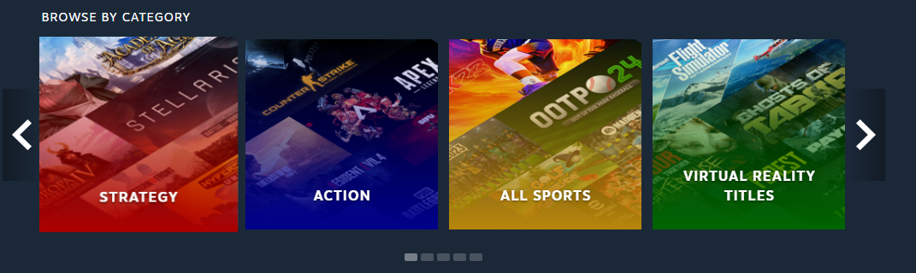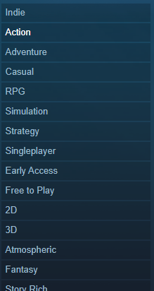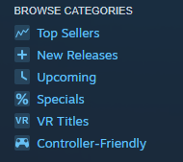

Figure 4 Screen shot Steam tags list taken on 29/03/2023

Figure Screen shot Steam side categories taken on 29/03/2023

Figure 5 Screenshot Steam categories taken on 29/03/2023

**Discussion**

Both of these systems have their flaws and merits. In this part, I will break down both systems and discuss what I think is good and bad.

Let’s start by breaking down *Steam* categories. Or at least what *Steam* calls categories in its header. Language is where the first problem occurs in *Steam*. If we look at *figure 5* we see that action is a category, which is also a genre if we look at *figure 1* and *figure 2*(And a tag, but that’s for the next section to be discussed). The other three available categories are also language failures. Why is horror a theme? What even is a theme? I couldn’t tell you. Player support is a very clear and nice category. It’s just a category/genre/tag that can help a user find games with a certain form of inter-player interaction. Lastly the special section. This is a bit of a special category as it shows some different things that aren’t genres but that could be very useful to users. I don’t have much to say about the special section and the player interaction section outside of good job *Steam* they are useful.

Tags are awesome. It allows users to tag a game with a tag(can we just call it a genre?). I found two problems with tags. First off, tags are useless for new games. As it requires users to give game tags, but this shouldn’t be a big problem. Also, I think developers can place tags when they release the game on *Steam*. The second and real problem is the users. When *Sekiro: shadows die twice*(FromSoftware. 2019) was released the game was tagged as comedy(I have no proof of this, but it happened) even do it’s a high-difficulty action adventure game where the players die all the time. Sekiro is not the only game that had this happen, many games on *Steam* are being tagged wrongfully. One of the communities favourite tag to place on games is psychological horror. Some examples of games that should not have the psychological horror tag but show up under it are *Mahjong Nagomi(*Zoo Corporation. 2020.*)*, *Animation Throwdown: The Quest for Cards (*Synapse Games and Chinzilla. 2017.*)* and *Mount your friends(*Stegersaurus Software Inc. 2014.*)*. The power of the user is something that has to be taken into account when using a system that is fully dependent on the users. Trolls(People who intentionally antagonize others online) are strong.

I can write a lot more about *Steam* and its genres, but I will stop here as I’m already way over the required word count. Some other things I could talk about are: Misuse of genres given by developers; Many genres aren’t available for searching through the given UI elements and some other HCI problems; How games get their genres(Shooter games never have the genre shooter); What are the available genres on *Steam* and what does *Steam* qualify as a genre; The misuse of tags as genres;

**Sources cited**

Altman, Rick. 1999. Movie/Genre. London: British Film Institute

FromSoftware. 2019. *Dark Souls*. Tokyo: Bandai Namco Entertainment

FromSoftware. 2011. *Sekiro: shadows die twice*. Tokyo: Bandai Namco Entertainment

Stegersaurus Software Inc. 2014. *Mount your friends.* Toronto, Canada: Stegersaurus Software Inc.

Synapse Games and Chinzilla. 2017. *Animation Throwdown: The Quest for Cards.* San Jose, California: Kongregate

Valve. 2003. *Steam*. Valve: Bellevue, Washington

Zoo Corporation. 2020. *Mahjong Nagomi. Ueda, Nagano, Japan*: Zoo Corporation